Camera Configuration | CDC.SoundLateralizationTask

Camera 17458434
Gain at 35
Exposure 536 us (default)

With Aeon Spinnaker Capture
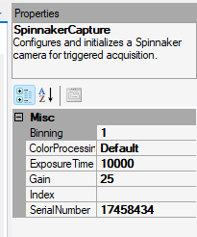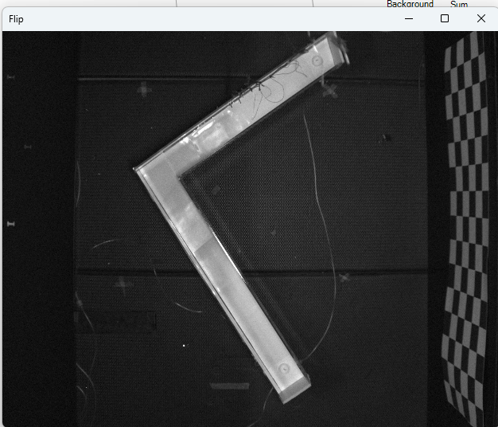

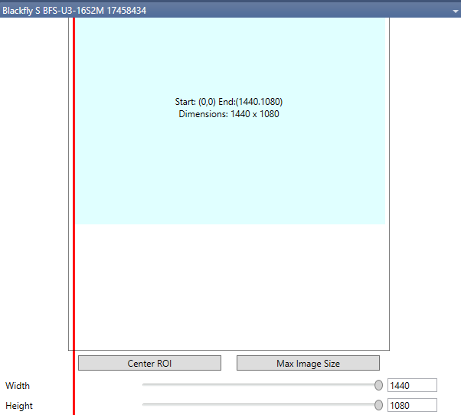
Make sure Max Image Size is clicked such that It captures full view

Camera 24166055 (Track 1)
Gain at 30
Exposure time 14998 (default)
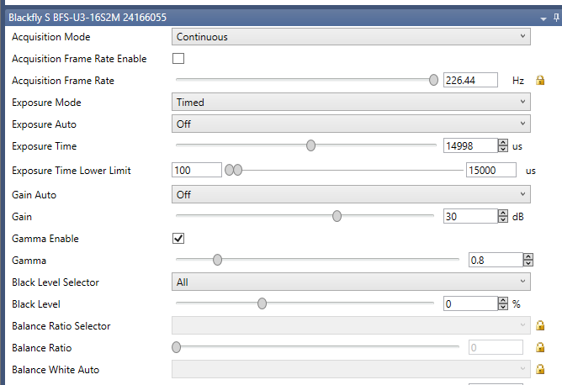

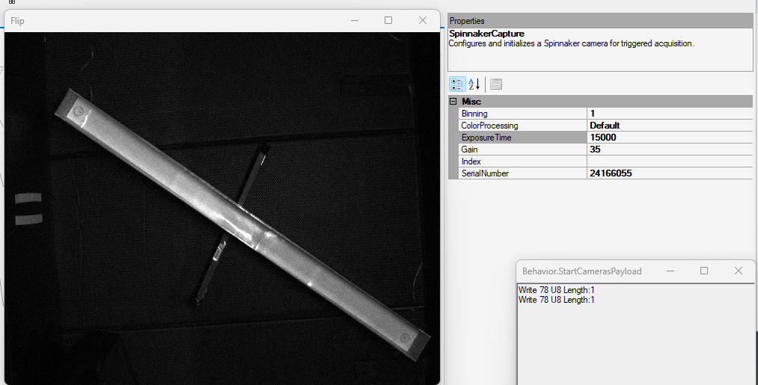
Now with Aeon package Spinnaker Capture

Camera 18474551
Gain at 18
Exposure Time 997 us
(But quality can be better with higher exposure time for brighter view)
(Not sure why, for this camera, using Aeon Camera capture causes delay to come back!)
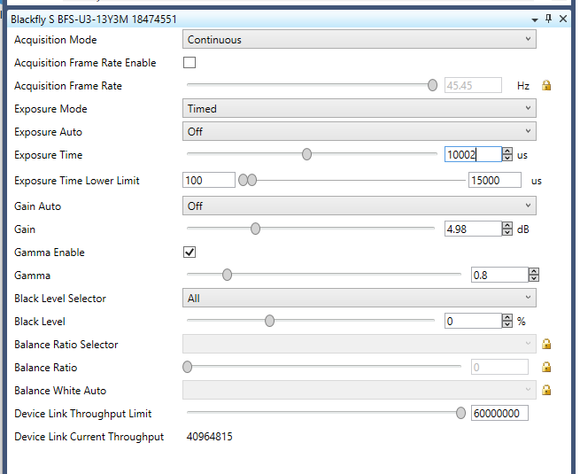

07/09/2026
